XFUSION FusionDirector For SCOM Plug-in
1.0.17
User Guide
 | Date | 2022-06-29
 | Copyright © Copyright Holder. All rights reserved.

Notice
The information in this document is subject to change without notice. Every effort has been made in the preparation of this document to ensure accuracy of the contents, but all statements, information, and recommendations in this document do not constitute a warranty of any kind, express or implied.

Contents
About This Document iv
1 Overview 6
2 Installing and Uninstalling the SCOM Plug-in 8
2.1 Installing the SCOM Plug-in 8
2.2 Uninstalling the SCOM Plug-in 17
2.2.1 Uninstalling the SCOM Plug-in from the Control Panel 17
2.2.2 Uninstalling the SCOM Plug-in from the Installation Directory 20
3 Configuring FusionDirector 23
3.1 Adding FusionDirector 23
3.2 Editing FusionDirector 27
3.3 Deleting FusionDirector 29
4 Viewing Plug-in System Information 32
4.1 Viewing the Basic Plug-in System Information and Status 32
4.2 Viewing a Plug-in System Event List 34
4.3 Viewing a Plug-in System Alarm List 35
5 Viewing Chassis Information 37
5.1 Viewing the Basic Chassis Information and Status 37
5.2 Viewing a Chassis Topology 40
5.3 Viewing a Chassis Alarm List 42
6 Viewing Server Information 44
6.1 Viewing the Basic Server Information and Status 44
6.2 Viewing a Server Topology 46
6.3 Viewing a Server Alarm List 47
6.4 Viewing Server Performance Curves 49
6.4.1 Viewing the CPU Usage 49
6.4.2 Viewing the Air Inlet Temperature 49
6.4.3 Viewing the PSU Power 50
7 FAQs 52
7.1 How Do I Fix a Communication Failure Caused by an Incorrect Default FusionDirector Certificate? 52
7.2 How Do I Replace the Server Certificate? 61
7.3 What Do I Do If the System Displays a Message Indicating that the SSL/TLS Secure Channel Fails to Be Created When FusionDirector Is Added? 71
7.4 How Do I Disable the Insecure TLS Protocol? 75
7.5 How to Disable System Unsafe Encryption Algorithm Kits 76
A Glossary 79
B Public IP Addresses 80
C Obtaining Technical Support 82
D Communication Matrix 83

About This Document
Purpose
This document describes how to install and uninstall the SCOM plug-in, add and delete FusionDirector, and view server information and status, alarm lists, and server topologies by using FusionDirector For SCOM Plugin.
Intended Audience
This document is intended for:
- Technical support engineers
- System maintenance engineers
Symbol Conventions
The symbols that may be found in this document are defined as follows.
Symbol | Description
 | Indicates an imminently hazardous situation which, if not avoided, will result in death or serious injury.
 | Indicates a potentially hazardous situation which, if not avoided, could result in death or serious injury.
 | Indicates a potentially hazardous situation which, if not avoided, may result in minor or moderate injury.
 | Indicates a potentially hazardous situation which, if not avoided, could result in equipment damage, data loss, performance deterioration, or unanticipated results.  NOTICE is used to address practices not related to personal injury.
Calls attention to important information, best practices and tips.
NOTE is used to address information not related to personal injury, equipment damage, and environment deterioration.

Change History
Changes between document issues are cumulative. The latest document issue contains all the changes made in earlier issues.
Issue | Date | Description
02 | 2022-06-29 | Add 7.5 How to Disable System Unsafe Encryption Algorithm Kits.
01 | 2022-06-06 | This issue is the first official release.

Overview
The SCOM plug-in is a plug-in integrated in the System Center Operations Manager (SCOM for short) software and used for server management. By adding FusionDirector, it can monitor the health status and alarm information of servers. A maximum of 1000 servers can be monitored.
You can implement the following functions by using the SCOM plug-in:
- View the information of servers and chassis.
- View the health status of servers and chassis.
- View the alarm information of servers and chassis.
- View the topologies of servers and chassis.
- View the performance curves of servers.


The actual functions depend on the functions provided by FusionDirector.
Servers supported by SCOM Plug-in
Type | Server or Chassis Model
Rack server | 1288H V5
Rack server | 2288 V5
Rack server | 2288H V5
Rack server | 2488 V5
Rack server | 2488H V5
Rack server | RH2288H V3
Rack server | 1288H V6
Rack server | 2288H V6
Blade server | CH121 V3
Blade server | CH242 V3
Blade server | CH121 V5
Blade server | CH242 V5
Blade server | E9000 (MM920)
KunLun server | 9008 V5

Matching Versions
Software | Matching Versions
FusionDirector | FusionDirector: 1.6.0.SPC1  FusionDirector: 1.6.1.SPC2  FusionDirector: 1.7.0  FusionDirector: 1.7.1.SPC2

Installing and Uninstalling the SCOM Plug-in
2.1 Installing the SCOM Plug-in
2.2 Uninstalling the SCOM Plug-in

Installing the SCOM Plug-in
Prerequisites
You have obtained the SCOM plug-in software package and verified its integrity.
- Obtain the SCOM plug-in software package (for example, XFUSION_FusionDirector_For_SCOM_Plugin_1.0.17.zip) and its SHA256 verification file (for example, XFUSION_FusionDirector_For_SCOM_Plugin_1.0.17.sha256.sum) from GitHub.
- Verify the integrity of the SCOM plug-in software package(Windows OS).
  - Open the CMD and go to the directory where the plug-in software package is stored.
  - Run the certutil -hashfile "software package name" sha256 command to check the SHA256 hash value of the software package.
Example: certutil -hashfile "XFUSION_FusionDirector_For_SCOM_Plugin_1.0.17.zip" sha256
  - Check whether the SHA256 hash value of the software package is the same as that of the SHA256 verification file.
  - If yes, the software package has not been tampered with and can be used.
  - If no, the software package has been tampered with. Obtain a new software package.
Procedure
            - Upload the SCOM plug-in installation package to the server.
            - Log in to the server.
            - Decompress the SCOM plug-in installation package.
Obtain the installation application, for example, XFUSION_FusionDirector_For_SCOM_Plugin_x.x.xx.xxx.exe.
            - Double-click XFUSION_FusionDirector_For_SCOM_Plugin_x.x.xx.xxx.exe.

If you set up the SCOM environment as an administrator and log in to the server as a non-administrator in Step 2, you need to run the plug-in installation program as an administrator.
The Installer Language window is displayed, as shown in Figure Installer Language.
              - Installer Language
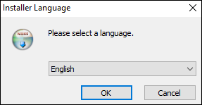

            - Select English, and click OK.
The welcome to the setup wizard window is displayed, as shown in Figure 2-2.
              - Welcome to the setup
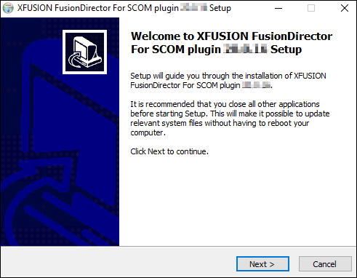

            - Click Next.
The Choose Install Location window is displayed, as shown in Figure 2-3.
              - Choose Install Location
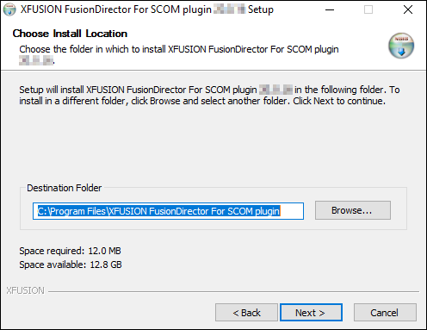

            - Retain the default installation path or click Browse to change the installation path, and click Next.
The Select features to install window is displayed, as shown in Figure 2-4.
              - Select features to install
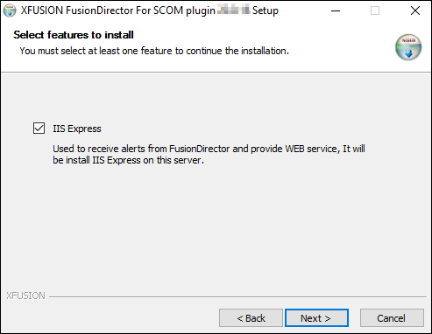

            - IIS Express is selected by default. Click Next.
The IP/Port Configuration window is displayed, as shown in Figure 2-5.
              - IP/Port Configuration
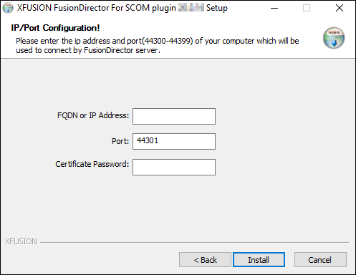

            - Enter the FQND or IP address, port number and certificate password of the server that is used to connect to FusionDirector. Click Install.
- The port number ranges from 44300 to 44399. You are advised to retain the default value 44301.
- Default certificate password is FusionCA.
The SCOM plug-in installation starts, as shown in Figure Installing the SCOM plug-in.
              - Installing the SCOM plug-in
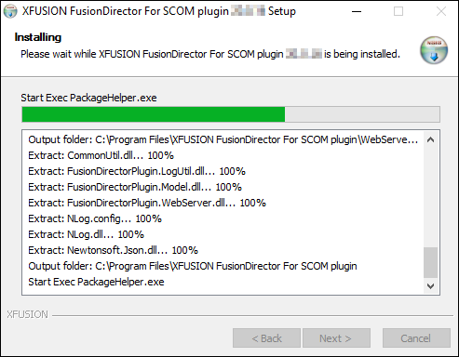

After the installation is complete, the completing the setup wizard is displayed, as shown in Figure 2-7.
              - Completing the setup
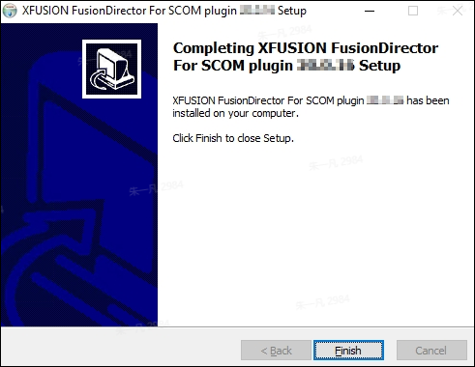

            - Click Finish.
The SCOM plug-in installation is complete.
After installation, replace the certificate as custom certificate. For details, see How Do I Replace the Server Certificate?.
            - Choose Start > > Operations Console.
The SCOM main window is displayed, as shown in Figure 2-8.
              - SCOM main window
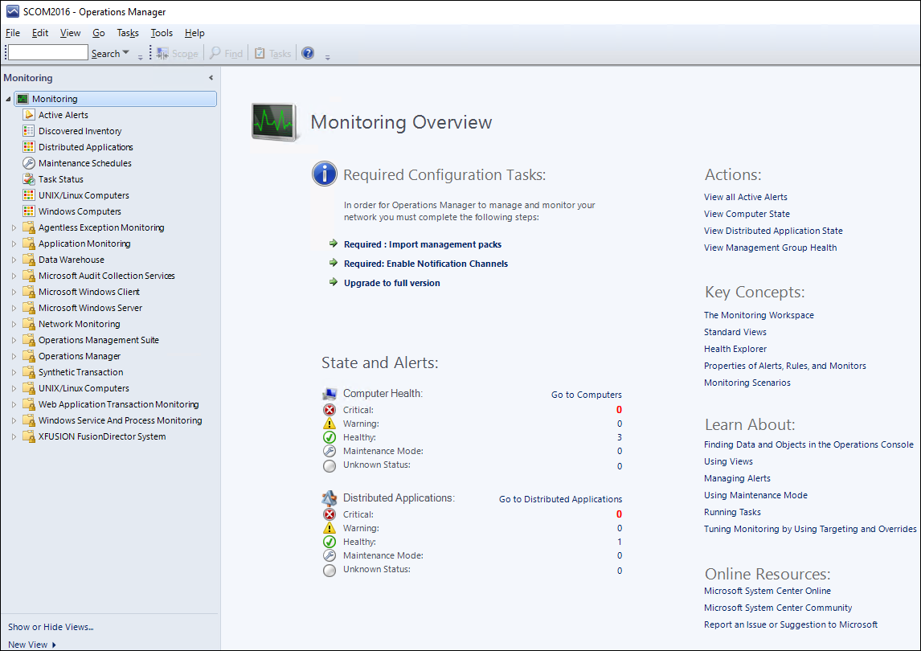

            - Choose Administration > Management Packs> Installed Management Packs.
The Installed Management Packs window is displayed, as shown in Figure Installed Management Packs.
              - Installed Management Packs
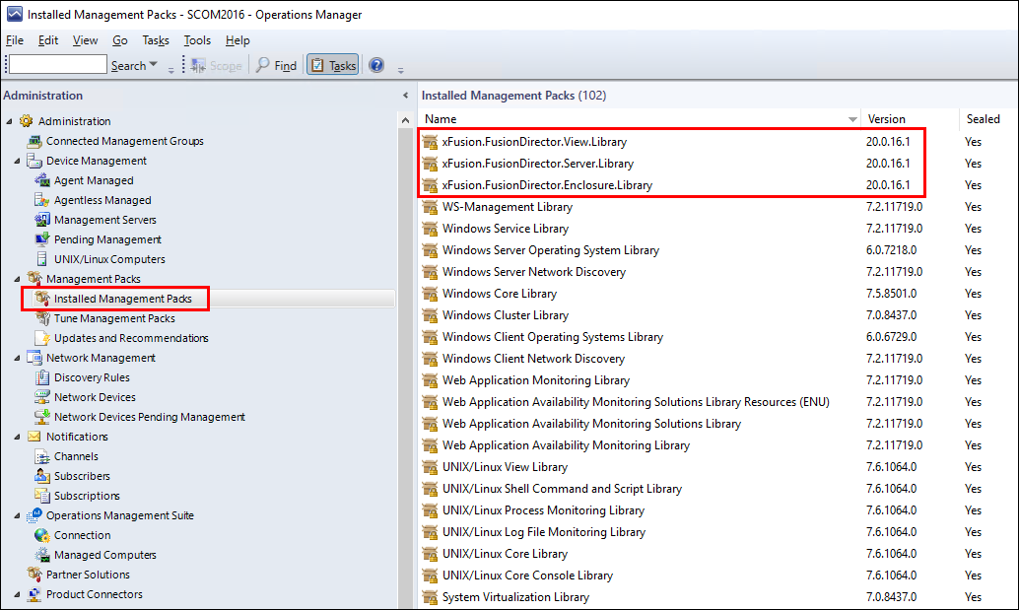

After the SCOM plug-in is successfully installed, the Manage Package (MP) packages in the red box are displayed in the Management Packs window.
After the MP packages are successfully installed, the nodes in the red box are displayed in the SCOM main window, as shown in Figure SCOM main window.
              - SCOM main window
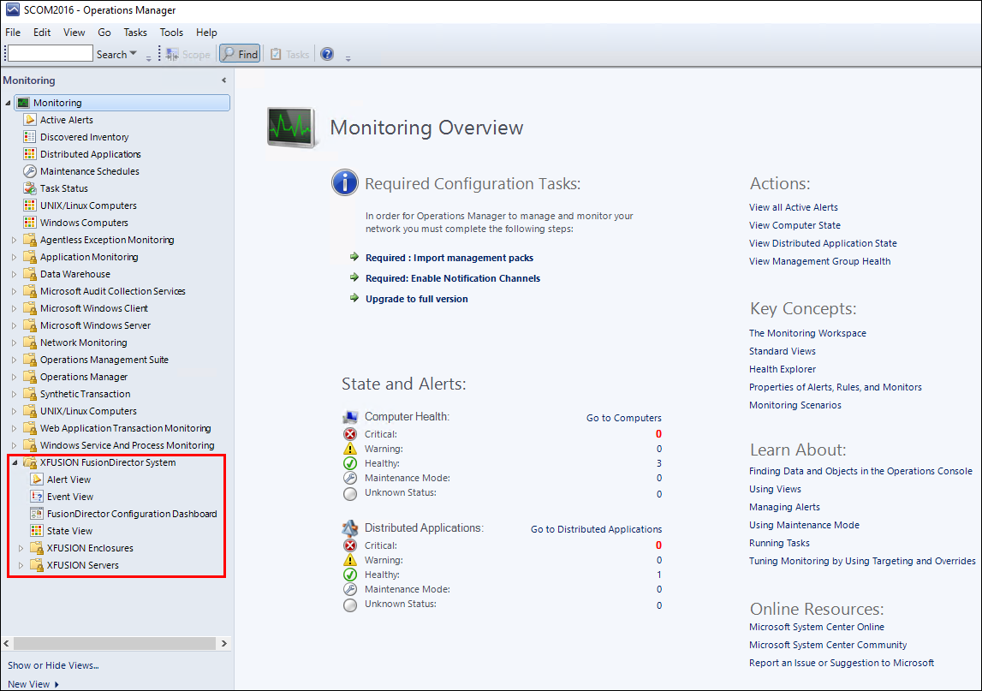

----End

Uninstalling the SCOM Plug-in
You need to close the SCOM window before uninstalling the SCOM plug-in.

Uninstalling the SCOM Plug-in from the Control Panel
            - Choose Start > Control Panel > Programs and Features > Uninstall a program.
The Uninstall or change a program window is displayed, as shown in Figure Uninstall or change a program.
              - Uninstall or change a program
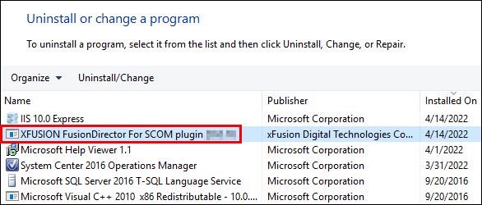

            - Double-click the SCOM plug-in (for example,XFUSION FusionDirector For SCOM plugin x.x.xx).
A confirmation dialog box is displayed, as shown in Figure Dialog box.
              - Dialog box
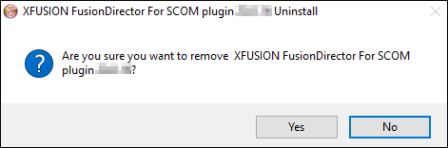

            - Click Yes.
The dialog box asking you whether to uninstall IIS Express is displayed, as shown in Figure 2-13.
              - Dialog box
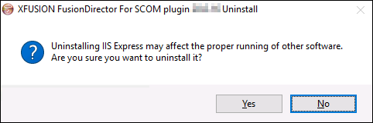

- IIS Express is responsible for the communication between the plug-in and FusionDirector. Uninstalling IIS Express may affect the proper running of other software. Exercise caution when performing this operation.
- If you uninstall IIS Express, it will be reinstalled when you install the SCOM plug-in again.
- If IIS Express needs to be uninstalled, click Yes.
- If IIS Express does not need to be uninstalled, click No.
            - Click Yes or No.
The SCOM plug-in uninstallation starts, as shown in Figure Uninstalling the SCOM plug-in.
              - Uninstalling the SCOM plug-in
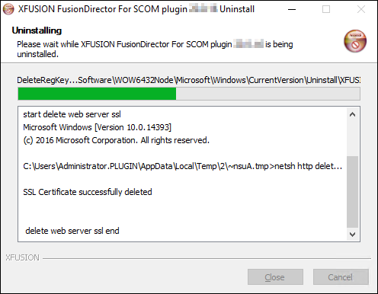

After the uninstallation is complete, the dialog box shown in Figure Uninstallation completed is displayed.
              - Uninstallation completed
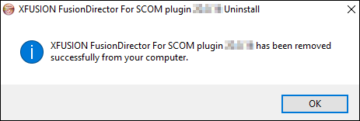

            - Click OK.
The SCOM plug-in is uninstalled.
----End

Uninstalling the SCOM Plug-in from the Installation Directory
            - Go to the installation directory of the SCOM plug-in (C:\Program Files\XFUSION Fusion Director For SCOM plugin by default), as shown in Figure Installation directory of the SCOM plug-in.
              - Installation directory of the SCOM plug-in
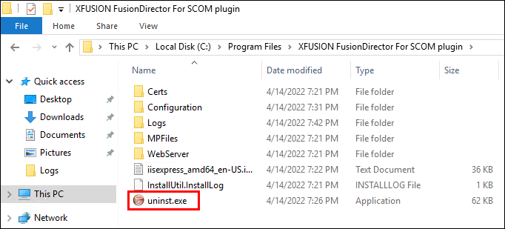

            - Double-click uninst.
A confirmation dialog box is displayed, as shown in Figure Dialog box.
              - Dialog box

            - Click Yes.
The dialog box asking you whether to uninstall IIS Express is displayed, as shown in Figure 2-18.
              - Dialog box

- IIS Express is responsible for the communication between the plug-in and FusionDirector. Uninstalling IIS Express may affect the proper running of other software. Exercise caution when performing this operation.
- If you uninstall IIS Express, it will be reinstalled when you install the SCOM plug-in again.
- If IIS Express needs to be uninstalled, click Yes.
- If IIS Express does not need to be uninstalled, click No.
            - Click Yes or No.
The SCOM plug-in uninstallation starts, as shown in Figure Uninstalling the SCOM plug-in.
              - Uninstalling the SCOM plug-in

After the uninstallation is complete, the dialog box shown in Figure Uninstallation completed is displayed.
              - Uninstallation completed

            - Click OK.
The SCOM plug-in is uninstalled.
----End

Configuring FusionDirector
3.1 Adding FusionDirector
3.2 Editing FusionDirector
3.3 Deleting FusionDirector

Adding FusionDirector
- A maximum of 10 FusionDirector instances can be added.
- When adding FusionDirector 1.6.1 or later on the Windows Server 2012 R2 environment with SCOM installed, you need to install the Windows OS patch (2919355) and add the cipher suite supported by FusionDirector. For details, see 7.3 What Do I Do If the System Displays a Message Indicating that the SSL/TLS Secure Channel Fails to Be Created When FusionDirector Is Added?.
            - Choose Start > > Operations Console.
The SCOM main window is displayed, as shown in Figure 3-1.
              - SCOM main window

            - Choose Monitoring > XFUSION FusionDirector System > FusionDirector Configuration View.
The FusionDirector Configuration Dashboard window is displayed, as shown in Figure FusionDirector Configuration Dashboard.
              - FusionDirector Configuration Dashboard
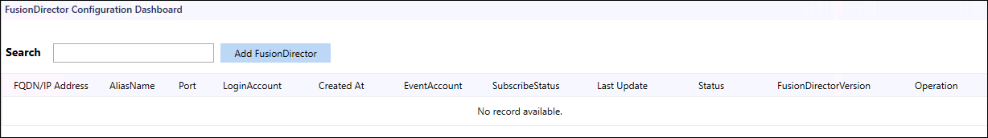

            - Click Add FusionDirector.
The Add FusionDirector dialog box is displayed, as shown in Figure 3-3.
              - Add FusionDirector
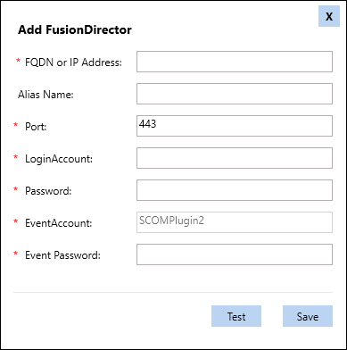

Table 3-1 describes the parameters in this dialog box.
                - Parameter description
Parameter | Description | Value | Mandatory
FQDN or IP Address | FQDN or IP address of FusionDirector. | The IP address format is XXX.XXX.XXX.XXX. Each X must be an integer. | Yes
Alias Name | Customized FusionDirector name. | The value is a string of 1 to 100 characters, including letters, digits, underscores (_), hyphens (-), and dots (.). | No
Port | FusionDirector port number. | The default value is 443. | Yes
LoginAccount | FusionDirector user name. | The default value is rootRedfish. | Yes
Password | FusionDirector password. | The default value is Machine@123. | Yes
Event Account | Alarm service account. | The value is automatically generated by the system. | Yes
Event Password | Alarm service password. | The password contains 8 to 32 characters, including uppercase letters, lowercase letters, digits, and special characters.  Special characters include '~!@$%^&*()-_=+|[{}];:'"",<>/?. | Yes

            - Enter FusionDirector information, and click Test to test whether the server can connect to FusionDirector.
If the test is successful, "Connect successful" is displayed, as shown in Figure 3-4. If the test fails, the failure cause is displayed. Modify FusionDirector information as prompted.
              - Successful test
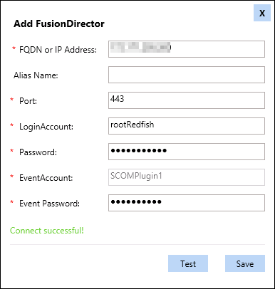

            - Click Save.
The FusionDirector is added successfully, as shown in Figure 3-5.
              - FusionDirector added successfully
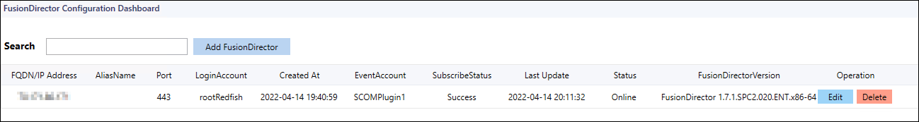

----End

Editing FusionDirector
            - Choose Start > > Operations Console.
The SCOM main window is displayed, as shown in Figure 3-6.
              - SCOM main window

            - Choose Monitoring > XFUSION FusionDirector System > FusionDirector Configuration Dashboard.
The FusionDirector Configuration Dashboard window is displayed, as shown in Figure FusionDirector Configuration Dashboard.
              - FusionDirector Configuration Dashboard

If the FusionDirector information is empty, no FusionDirector is added.
            - In the Operation column, click Edit.
The Edit FusionDirector dialog box is displayed, as shown in Figure 3-8.
              - Edit FusionDirector
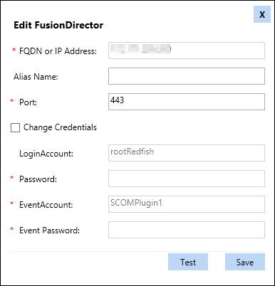

            - Edit the FusionDirector information according to Table 3-1, and click Save.

- The FusionDirector IP address cannot be modified.
- You can change the FusionDirector user name and password only after selecting Change Credentials. After changing the user name and password, click Test.
The FusionDirector is successfully edited, as shown in Figure 3-9. In this window, you can check whether the modified information is consistent with the target.
              - Modified FusionDirector information

----End

Deleting FusionDirector
            - Choose Start > > Operations Console.
The SCOM main window is displayed, as shown in Figure 3-10.
              - SCOM main window

            - Choose Monitoring > XFUSION FusionDirector System > FusionDirector Configuration Dashboard.
The FusionDirector Configuration Dashboard window is displayed, as shown in Figure FusionDirector Configuration Dashboard.
              - FusionDirector Configuration Dashboard

If the FusionDirector information is empty, no FusionDirector is added.
            - In the Operation column, click Delete.
The Delete FusionDirector dialog box is displayed, as shown in Figure 3-12.
              - Delete FusionDirector
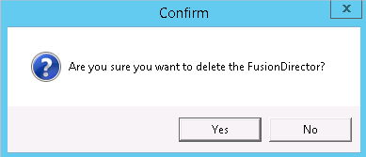

            - Click OK.
The FusionDirector is successfully deleted, as shown in Figure 3-13. In this window, you can check whether the target FusionDirector is deleted.
              - FusionDirector deleted successfully

----End

Viewing Plug-in System Information
4.1 Viewing the Basic Plug-in System Information and Status
4.2 Viewing a Plug-in System Event List
4.3 Viewing a Plug-in System Alarm List

Viewing the Basic Plug-in System Information and Status
            - Choose Start > > Operations Console.
The SCOM main window is displayed.
            - Choose Monitoring > XFUSION FusionDirector System > State View.
The State View window is displayed, as shown in Figure 4-1.
              - State View
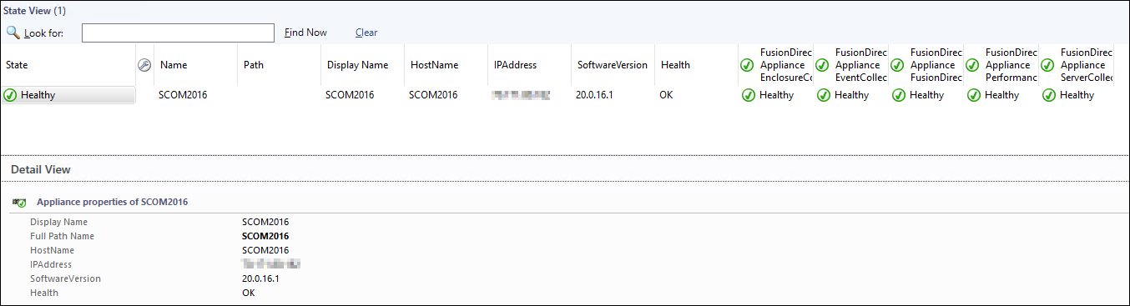

Each column in this window displays the running status of each function of the plug-in.
- FusionDirector Appliance EnclosureCollection: chassis monitoring function
- FusionDirector Appliance EventCollection: event monitoring function
- FusionDirector Appliance FusionDirectorCollection: FusionDirector monitoring function
- FusionDirector Appliance PerformanceCollection: performance curve monitoring function
- FusionDirector Appliance ServerCollection: server monitoring function
You can click anywhere in the row of the plug-in in the State View area to view details about the plug-in in the Detail View area.
The component health status is described as follows:
- : healthy
- : minor alarms
- : major or critical alarms
            - Set the parameters to be displayed.
- Right-click a plug-in name or monitoring status and choose Personalize View... from the shortcut menu.
The Personalize View window is displayed, as shown in Figure 4-2.
              - Personalize View
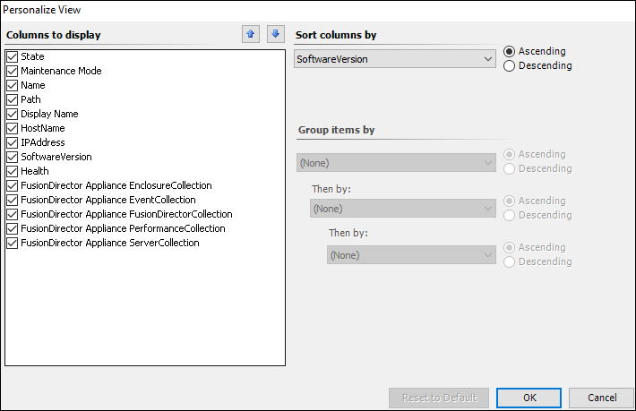

- Select parameters to be viewed and click OK.
The parameters to be viewed are modified successfully.
----End

Viewing a Plug-in System Event List
            - Choose Start > > Operations Console.
The SCOM main window is displayed.
            - Choose Monitoring > XFUSION FusionDirector System > Event View.
The Event View window is displayed. You can click the event to be viewed to view the details of the event in the Event Data area, as shown in Figure 4-3.
              - Event View
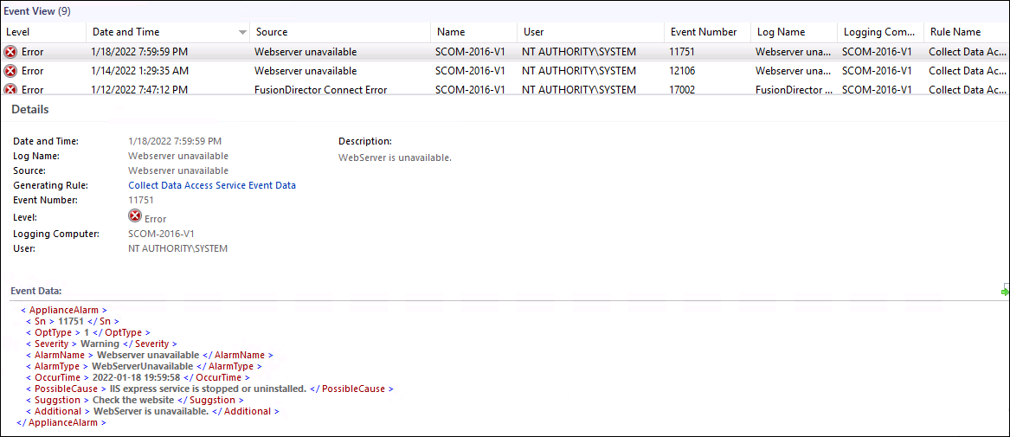

Table 4-1 describes the parameters.
                - Parameter description
Parameter | Description
Level | Event type. The options are as follows:  - Information: running event  - Warning: minor alarm  - Error: major or critical alarm
Date and Time | Date and time when the event is generated.
Source | Event source, which is the component where the event is generated.
Name | Device where the event is generated.
User | Current user.
Event Number | Event number.
Log Name | Event name.
Logging Computer | Current login device.
Rule Name | Rule name.

----End

Viewing a Plug-in System Alarm List
            - Choose Start > > Operations Console.
The SCOM main window is displayed.
            - Choose Monitoring > XFUSION FusionDirector System > Alert View.
The Alert View window is displayed. You can click an alarm to view its details, as shown in Figure 4-4.
              - Alert View
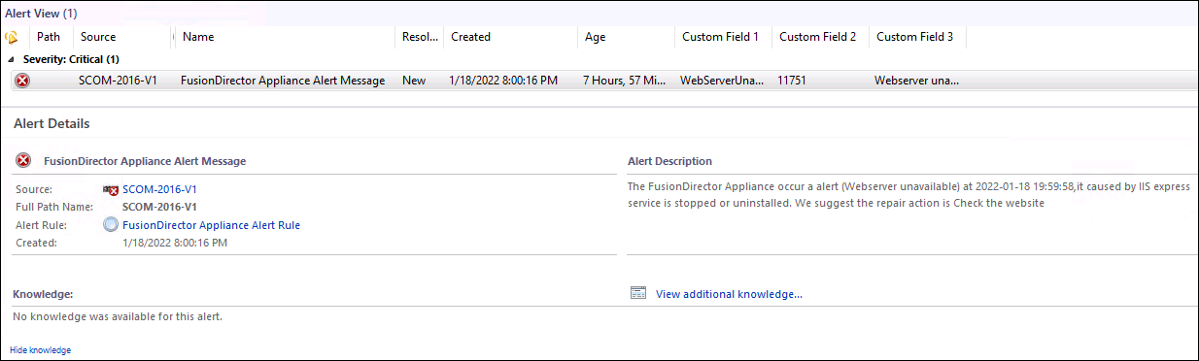

Table 4-2 describes the parameters.
                - Parameter description
Parameter | Description
lcon | Alarm type. The options are as follows:  - Warning: minor alarm  - Critical: major or critical alarm
Path | Sensor that generates the alarm.
Source | Device where the alarm is generated.
Maintenance Mode | Maintenance mode.
Name | Alarm name.
Resolution State | Handling status.
Created | Time when the alarm is generated.
Age | Duration of the alarm.
Owner | Owner.
Priority | Priority.
Latency | Latency.
Description | Alarm description.
Class | Alarm type.
Time in State | Alarm duration.
Repeat Count | Number of repeated occurrence times.
Custom Field 1 | Alarm type.
Custom Field 2 | Alarm code.
Custom Field 3 | Alarm name.
Custom Field 4 | Possible cause.
Custom Field 5 | Remarks.
Custom Field 6 | Alarm clearance suggestion.
Custom Field 7 | Alarm occurrence time.
----End

Viewing Chassis Information
5.1 Viewing the Basic Chassis Information and Status
5.2 Viewing a Chassis Topology
5.3 Viewing a Chassis Alarm List

Viewing the Basic Chassis Information and Status
            - Choose Start > > Operations Console.
The SCOM main window is displayed.
            - Choose Monitoring > XFUSION FusionDirector System >XFUSION Enclosures > State View.
The State View window is displayed, as shown in Figure 5-1. In this window, the managed chassis are displayed in different rows and monitoring parameters of chassis are displayed in different columns.
              - State View
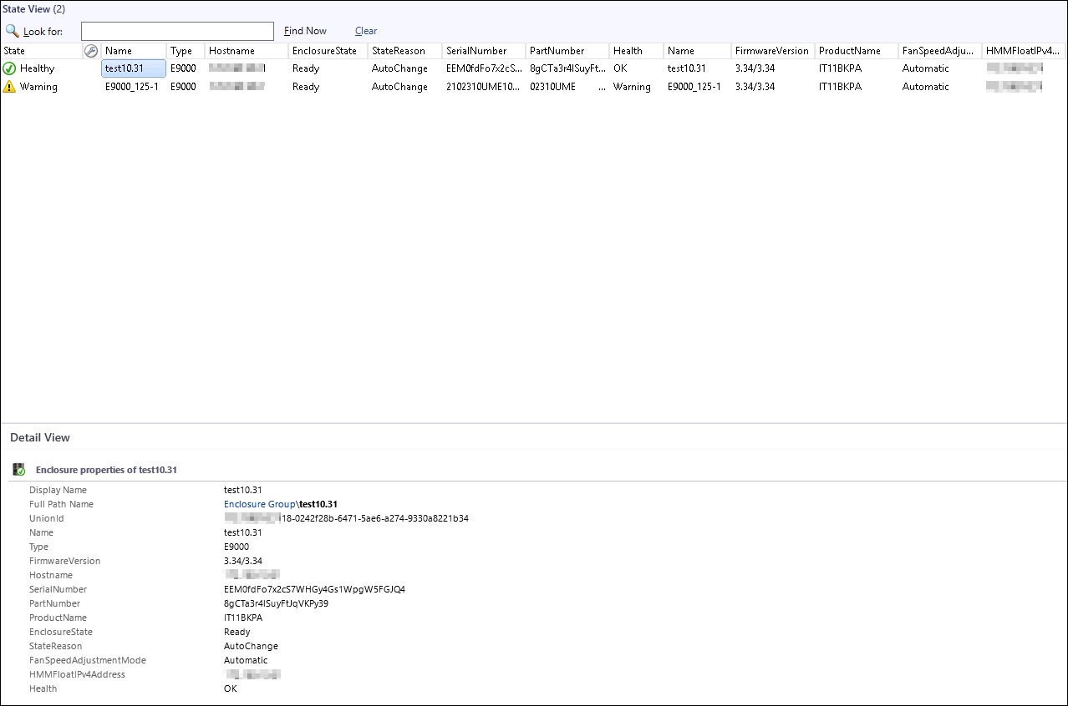

In the State View area, you can click any position in the row of a chassis to view details about the chassis in the Detail View area.
The chassis health status is described as follows:
- : healthy
- : minor alarms
- : major or critical alarms
            - Set the parameters to be displayed.
- Right-click a chassis name and choose Personalize View... from the shortcut menu.
The Personalize View window is displayed, as shown in Figure 5-2.
              - Personalize View
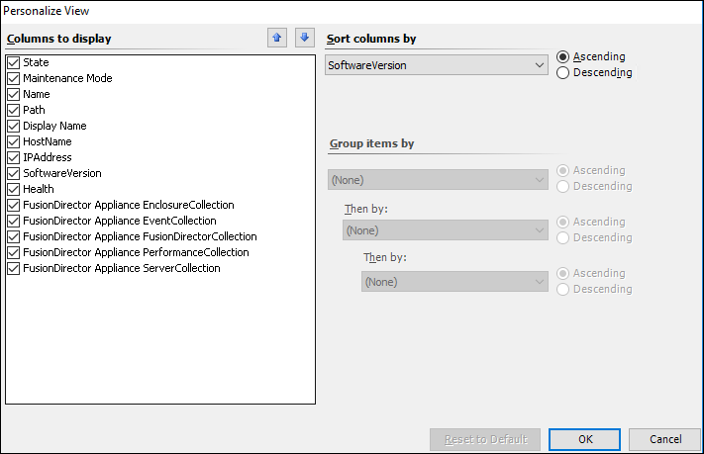

- Select parameters to be viewed and click OK.
The parameters to be viewed are modified successfully.
Table 5-1 describes the parameters that can be viewed by the SCOM plug-in.
                - Components and parameters that can be viewed
Parameter | Description
State | Chassis presence status.
Name | Server name.
Type | Server model.
Hostname | Host name.
StateReason | Reason of the chassis presence status.
SerialNumber | Serial number.
PartNumber | Component number.
Health | Chassis health status.
FirmwareVersion | HMM version.
ProductName | Product name.
FanSpeedAdjustmentMode | Fan speed adjustment mode.
HMMFloatIPv4Address | HMM floating IP address.

----End

Viewing a Chassis Topology
            - Choose Start > > Operations Console.
The SCOM main window is displayed.
            - Choose Monitoring > XFUSION FusionDirector System >XFUSION Enclosures > Diagram View.
The Diagram View window is displayed, as shown in Figure 5-3.
              - Diagram View
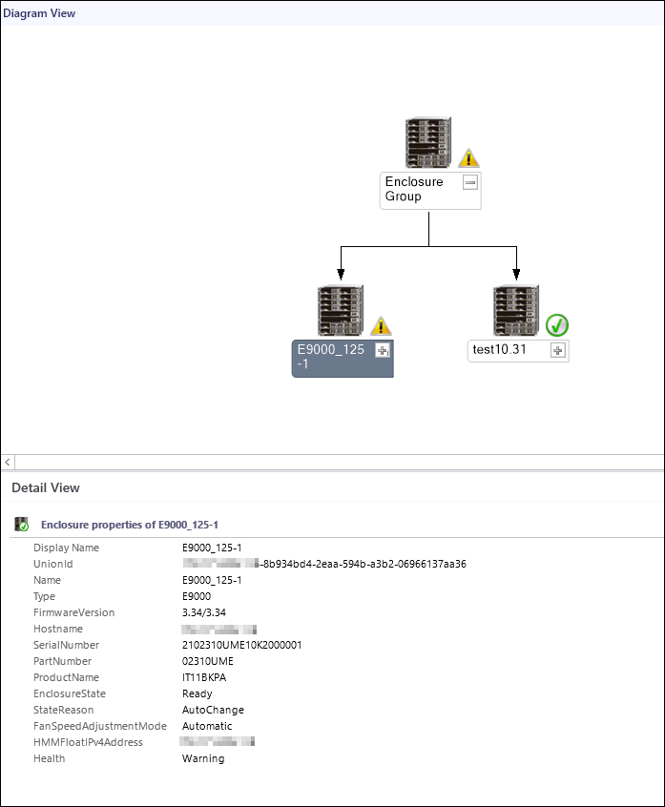

If the topology is not refreshed in time, you can perform the following steps to refresh it:
            - Open the CLI of the server.
            - Access the SCOM installation path (C:\Program Files\System Center Operations Manager 2012\Console) on the CLI.
            - Run the following command to refresh the SCOM window:
Microsoft.EnterpriseManagement.Monitoring.Console.exe" /clearcache
----End

Viewing a Chassis Alarm List
            - Choose Start > > Operations Console.
The SCOM main window is displayed.
            - Choose Monitoring > XFUSION FusionDirector System > XFUSION Enclosures > Alert View.
In the Alert View window that is displayed, click an alarm to view its details, as shown in Figure 5-4.
The FusionDirector that is added for the first time synchronously displays historical alarms that are not cleared.
              - Alert View
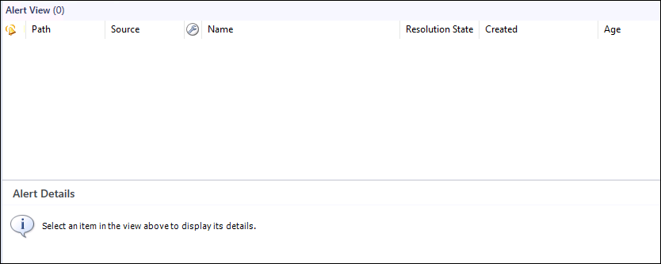

Table 5-2 describes the parameters.
                - Parameter description
Parameter | Description
lcon | Alarm type. The options are as follows:  - Warning: minor alarm  - Critical: major or critical alarm
Path | Sensor that generates the alarm.
Source | Device where the alarm is generated.
Maintenance Mode | Maintenance mode.
Name | Alarm name.
Resolution State | Handling status.
Created | Time when the alarm is generated.
Age | Duration of the alarm.
Owner | Owner.
Priority | Priority.
Latency | Latency.
Description | Alarm description.
Class | Alarm type.
Time in State | Alarm duration.
Repeat Count | Number of repeated occurrence times.
----End

Viewing Server Information
6.1 Viewing the Basic Server Information and Status
6.2 Viewing a Server Topology
6.3 Viewing a Server Alarm List
6.4 Viewing Server Performance Curves

Viewing the Basic Server Information and Status
            - Choose Start > > Operations Console.
The SCOM main window is displayed.
            - Choose Monitoring > XFUSION FusionDirector System > XFUSION Servers > State View.
The State View window is displayed, as shown in Figure 6-1. In this window, the managed servers are displayed in different rows and status monitoring parameters of monitored components on each server are displayed in different columns.
              - State View
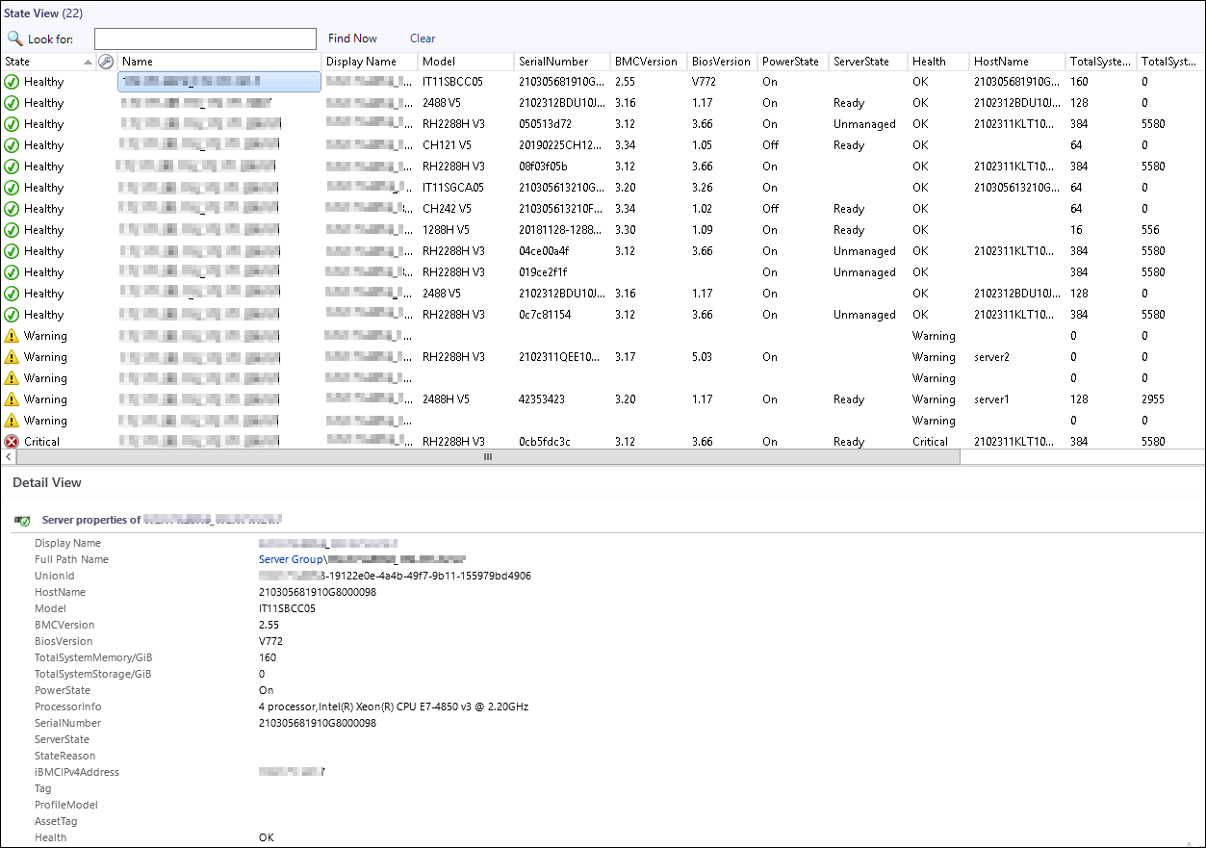

In the State View area, you can click any position in the row of a server to view details about the server in the Detail View area.
The server health status is described as follows:
- : healthy
- : minor alarms
- : major or critical alarms
            - Set the parameters to be displayed. For details, see Step 3 in 5.1 Viewing the Basic Chassis Information and Status.
Table 6-1 describes server parameters that can be monitored by the SCOM plug-in.
                - Parameter description
Parameter | Description
State | Server presence status.
Model | Server model.
SerialNumber | Serial number.
Tag | Server tag.
AssetTag | Asset tag.
BMCVersion | iBMC version.
BiosVersion | BIOS version.
PowerState | Power status.
Health | Server health status.
HostName | Host name.
TotalSystemMemory/GiB | Memory size.
TotalSystemStorage/GiB | Storage size.
ProcessorInfo | CPU information.
StateReason | Reason of the server presence status.
iBMCIPv4Address | iBMC IP address.
ProfileModel | Configuration file type.
UUID | Universally Unique Identifier.

----End

Viewing a Server Topology
            - Choose Start > > Operations Console.
The SCOM main window is displayed.
            - Choose Monitoring > XFUSION FusionDirector System > XFUSION Servers > Diagram View.
The Diagram View window is displayed, as shown in Figure 6-2.
              - Diagram View
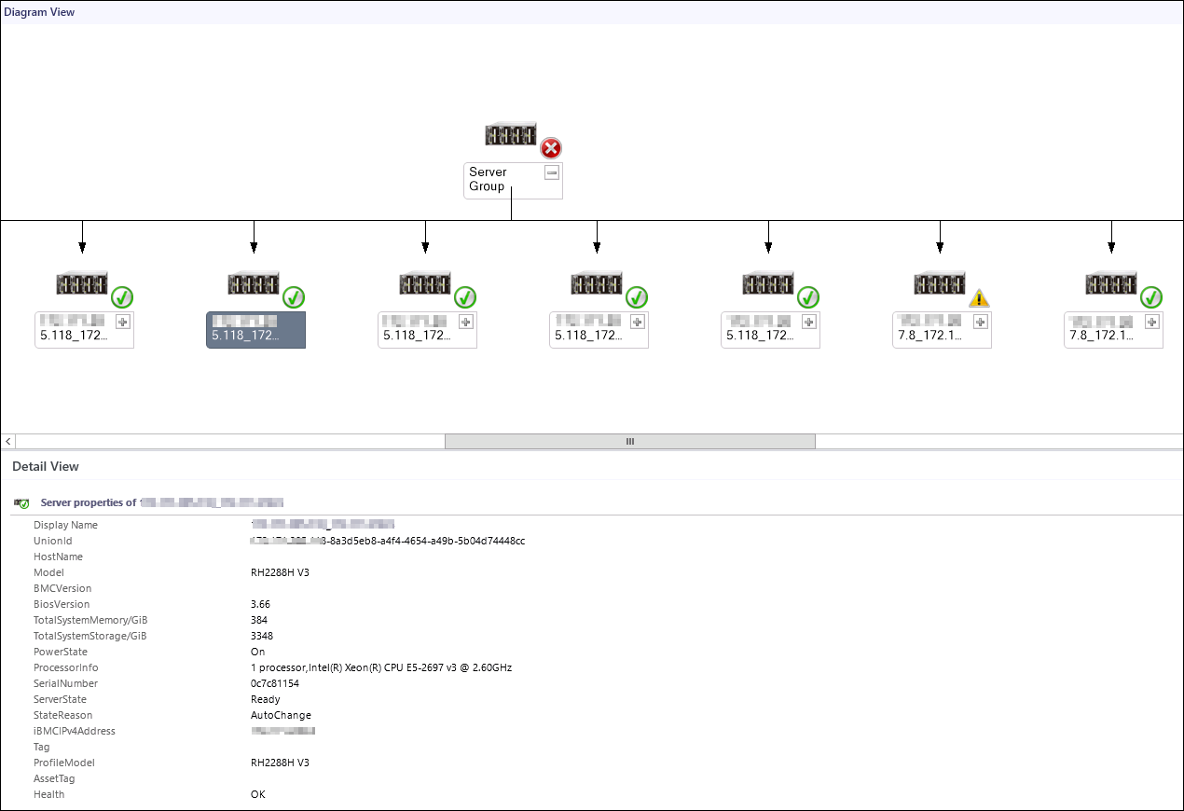

If the topology is not refreshed in time, you can perform the following steps to refresh it:
            - Open the CLI of the server.
            - Access the SCOM installation path (C:\Program Files\System Center Operations Manager 2012\Console) on the CLI.
            - Run the following command to refresh the SCOM window:
Microsoft.EnterpriseManagement.Monitoring.Console.exe" /clearcache
----End

Viewing a Server Alarm List
            - Choose Start > > Operations Console.
The SCOM main window is displayed.
            - Choose Monitoring > xFuson FusionDirector System > XFUSION Servers > Alert View.
In the Alert View window that is displayed, click an alarm to view its details, as shown in Figure 6-3.
The FusionDirector that is added for the first time synchronously displays historical alarms that are not cleared.
              - Alert View
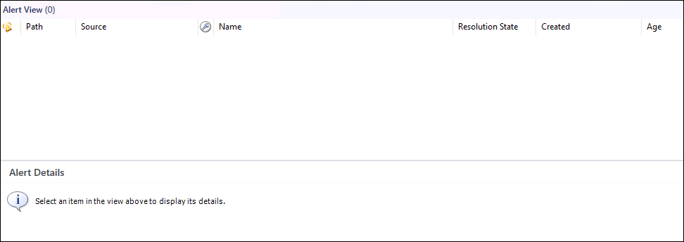

Table 6-2 describes the parameters.
                - Parameter description
Parameter | Description
lcon | Alarm type. The options are as follows:  - Warning: minor alarm  - Critical: major or critical alarm
Path | Sensor that generates the alarm.
Source | Device where the alarm is generated.
Maintenance Mode | Maintenance mode.
Name | Alarm name.
Resolution State | Handling status.
Created | Time when the alarm is generated.
Age | Duration of the alarm.
Owner | Owner.
Priority | Priority.
Latency | Latency.
Description | Alarm description.
Class | Alarm type.
Time in State | Alarm duration.
Repeat Count | Number of repeated occurrence times.

----End

Viewing Server Performance Curves
You can view performance curves only of servers whose ServerState is Ready.

Viewing the CPU Usage
            - Choose Start > > Operations Console.
The SCOM main window is displayed.
            - Choose Monitoring > XFUSION FusionDirector System > XFUSION Servers > Performance View > CPU Usage(%).
The CPU Usage(%) window is displayed, as shown in Figure 6-4.
              - CPU Usage(%)
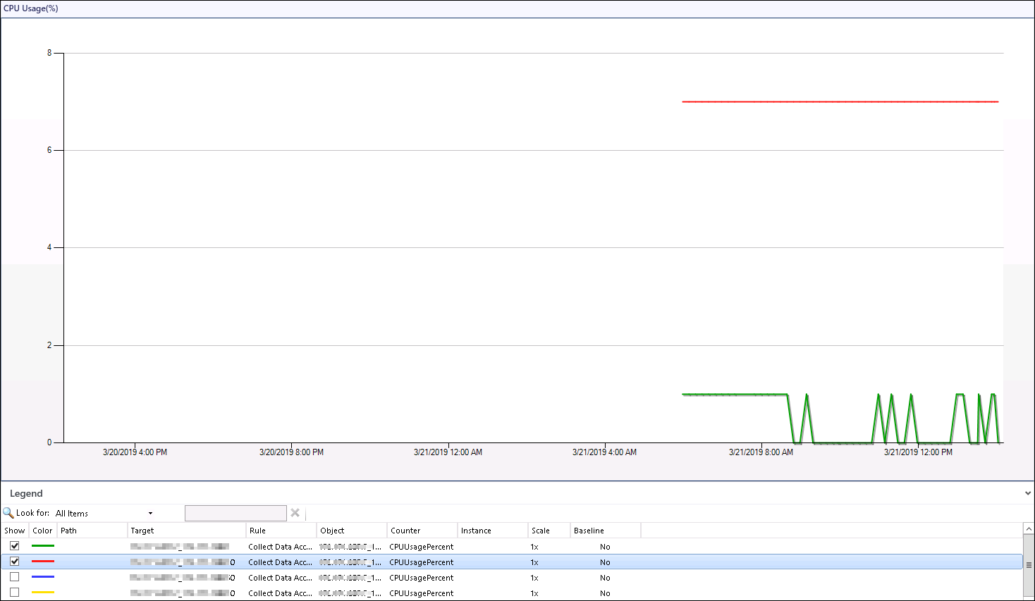

            - Select servers in the Legend area to view the CPU usage curves of the servers.
----End

Viewing the Air Inlet Temperature
            - Choose Start > > Operations Console.
The SCOM main window is displayed.
            - Choose Monitoring > XFUSION FusionDirector System > XFUSION Servers > Performance View > Inlet Temp(Centigrade).
The Inlet Temp(Centigrade) window is displayed, as shown in Figure 6-5.
              - Inlet Temp(Centigrade)
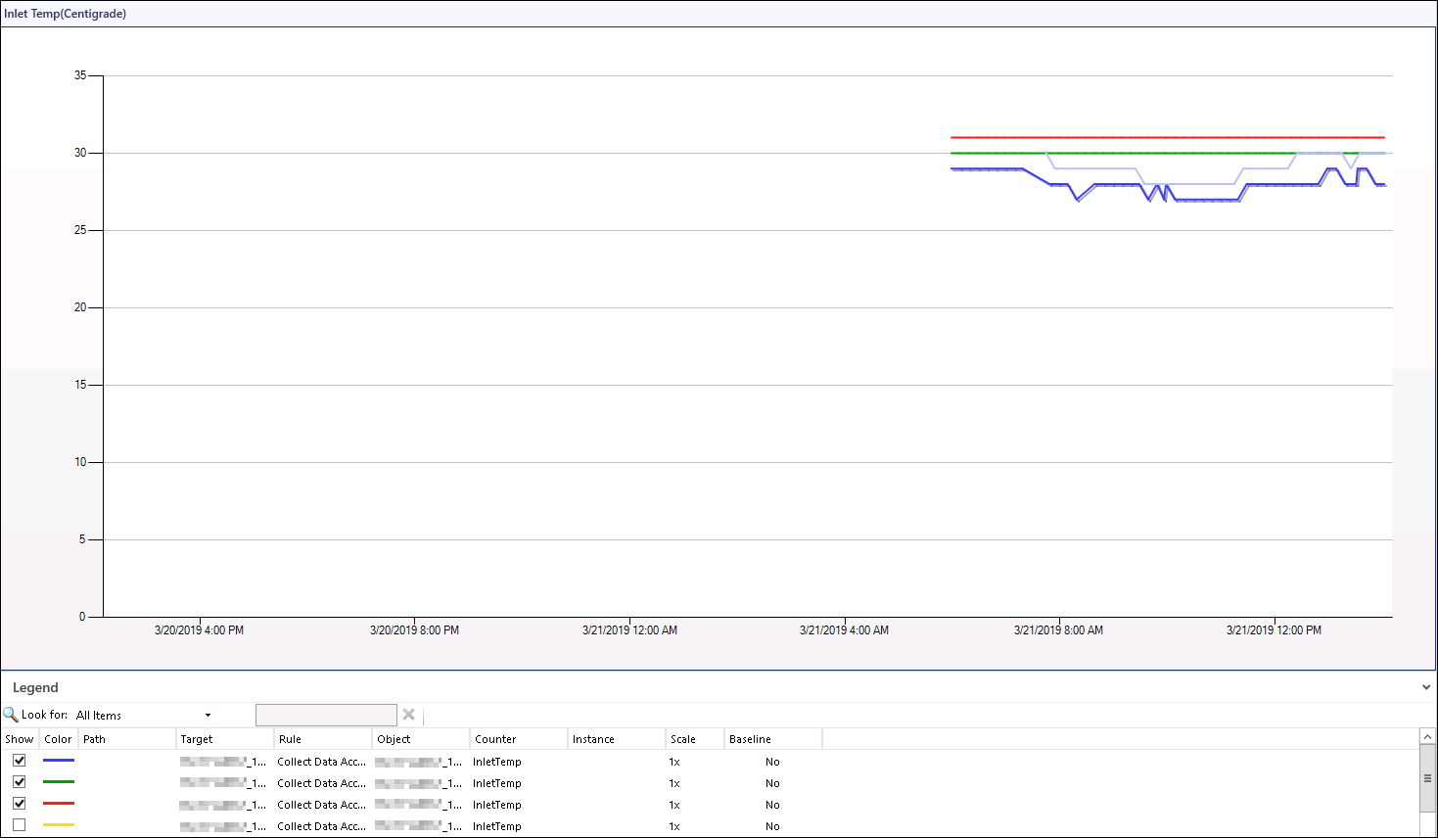

            - Select servers in the Legend area to view the air inlet temperature curves of the servers.
----End

Viewing the PSU Power
            - Choose Start > > Operations Console.
The SCOM main window is displayed.
            - Choose Monitoring > XFUSION FusionDirector System > XFUSION Servers > Performance View > Power Consumed(Watts).
The Power Consumed(Watts) window is displayed, as shown in Figure 6-6.
              - Power Consumed(Watts)
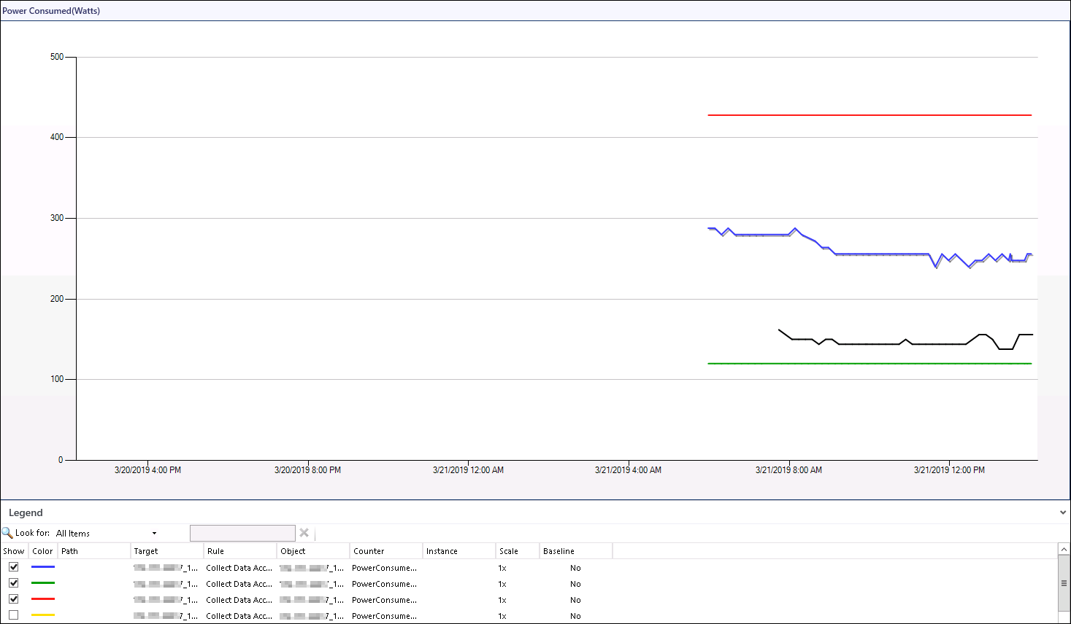

            - Select servers in the Legend area to view the PSU power curves of the servers.
----End

FAQs
7.1 How Do I Fix a Communication Failure Caused by an Incorrect Default FusionDirector Certificate?
7.2 How Do I Replace the Server Certificate?
7.3 What Do I Do If the System Displays a Message Indicating that the SSL/TLS Secure Channel Fails to Be Created When FusionDirector Is Added?
7.4 How Do I Disable the Insecure TLS Protocol?
7.5 How to Disable System Unsafe Encryption Algorithm Kits

How Do I Fix a Communication Failure Caused by an Incorrect Default FusionDirector Certificate?
Symptom
If the default FusionDirector certificate is modified or replaced after this plug-in is added to FusionDirector, the plug-in fails to communicate with FusionDirector.
Solution
Manually upload the modified or replaced Fusion Director certificate. The following procedure uses upload of the FusionDirector certificate as an example.
- Uploading the Root Certificate
  - Double-click the root certificate xFusionE... of FusionDirector.
The Certificate window is displayed, as shown in Figure 7-1.
              - Certificate
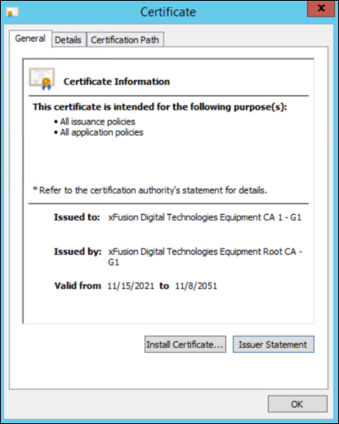

  - Click Install Certificate....
The Certificate Import Wizard window is displayed, as shown in Figure 7-2.
              - Certificate Import Wizard
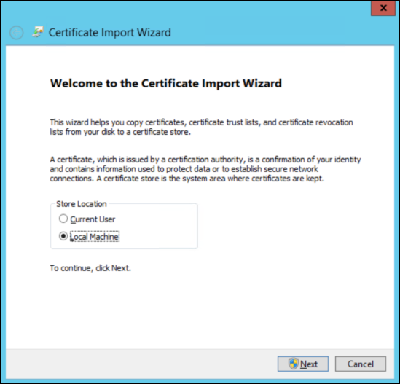

  - Select Local Machine and click Next.
The Certificate Store window is displayed, as shown in Figure 7-3.
              - Certificate Stone
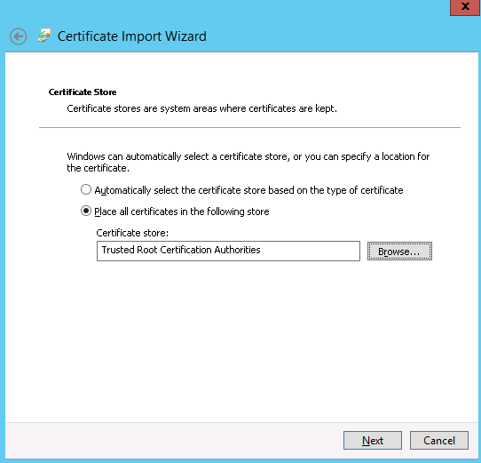

  - Select Place all Certificates in following store.
  - Click Browse…, select Trusted Root Certification Authorities, and click Next.
The Completing the Certificate Import Wizard window is displayed, as shown in Figure 7-4.
              - Completing the Certificate Import Wizard
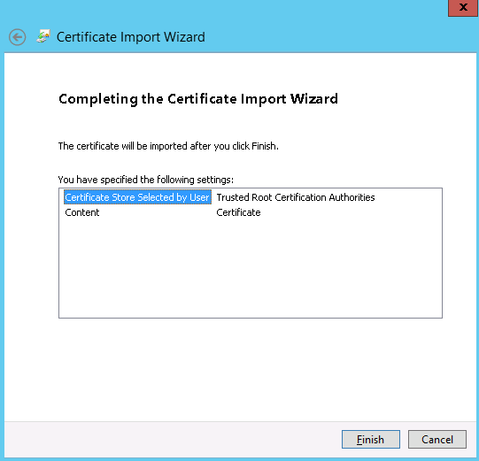

  - Click Finish.
A dialog box indicating import success is displayed, as shown in Figure 7-5.
              - Import success
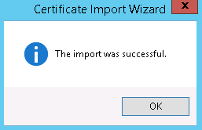

  - Click OK.
  - On the Figure 7-1 page, click OK. The certificate is imported.
- Uploading the Product Certificate
  - Double-click the product certificate xFusionITProductCA of FusionDirector.
The Certificate window is displayed, as shown in Figure 7-6.
              - Certificate
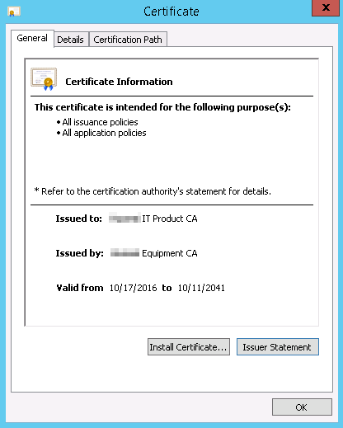

  - Click Install Certificate....
The Certificate Import Wizard window is displayed, as shown in Figure 7-7.
              - Certificate Import Wizard

  - Select Local Machine and click Next.
The Certificate Store window is displayed, as shown in Figure 7-8.
              - Certificate Store
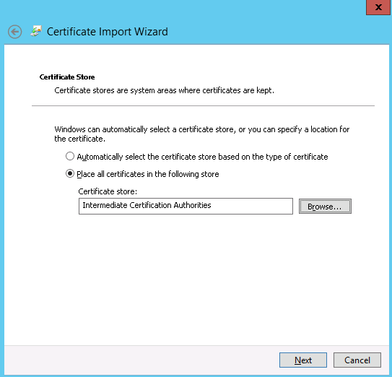

  - Select Place all Certificates in following store.
  - Click Browse…, select Intermediate Certification Authorities, and click Next.
The Completing the Certificate Import Wizard window is displayed, as shown in Figure 7-9.
              - Completing the Certificate Import Wizard
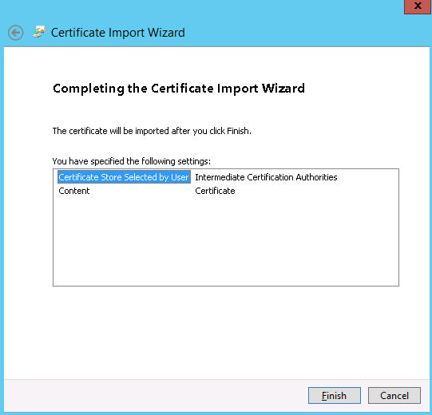

  - Click Finish.
A dialog box indicating import success is displayed, as shown in Figure 7-10.
              - Import success

  - Click OK.
  - On the Figure 7-6 page, click OK. The certificate is imported.

How Do I Replace the Server Certificate?
            - Import the root certificate on the FusionDirector WebUI.
- Choose System Settings > Security > Certificates. The Certificate page is displayed, as shown by (1) in Figure 7-11.
              - Importing the root certificate
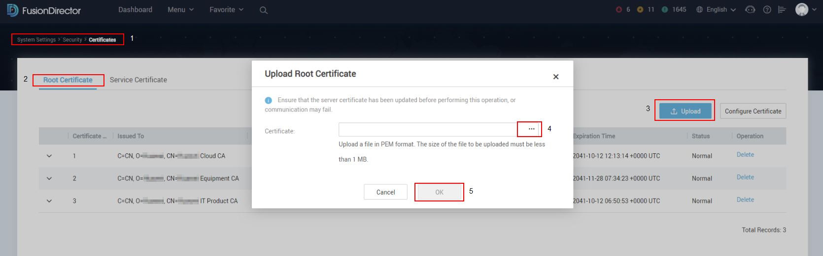

- Choose Root Certificate, as shown by (2) in Figure 7-11.
- On the Root Certificate page, click Upload, as shown by (3) in Figure 7-11.
The Upload Root Certificate dialog box is displayed.
- Select the root certificate to be imported and click OK, as shown by (4) and (5) in Figure 7-11.
            - In the SCOM plug-in environment, save the server certificate to be imported to the following path, as shown in Figure 7-12.
C:\Program Files\XFUSION Fusion Director For SCOM plugin\Certs
              - Certificate path
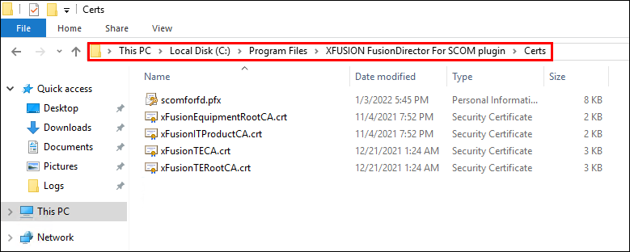

            - Double-click the certificate to start the installation.
The Welcome to the Certificate Import Wizard page is displayed, as shown in Figure 7-13.
              - Welcome to the Certificate Import Wizard page
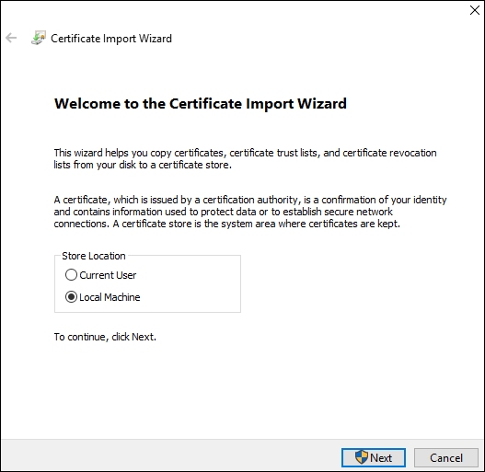

            - Select Local Machine and click Next.
The File to Import page is displayed, as shown in Figure 7-14.
              - File to Import page
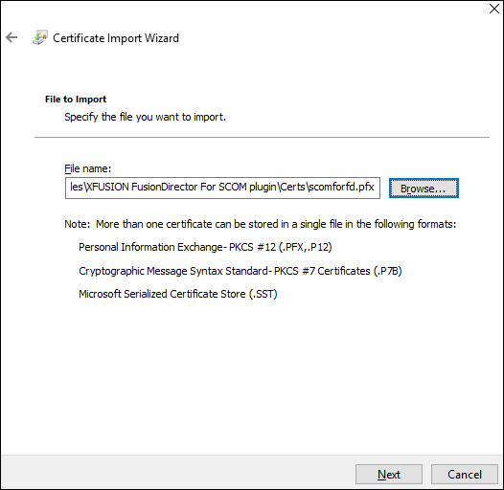

            - Retain the default file path and click Next.
The Private key protection page is displayed, as shown in Figure 7-15.
              - Private key protection page
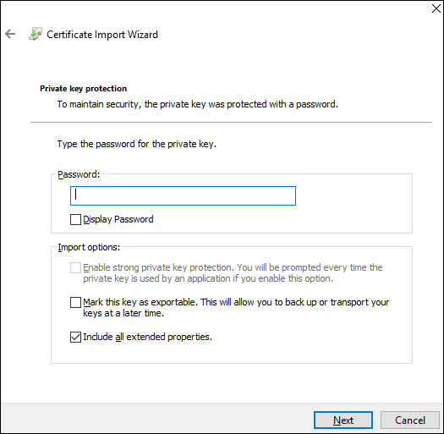

            - Enter the password (which is set by the user during certificate generation) and click Next.
The Certificate Store page is displayed, as shown in Figure 7-16.
              - Certificate Store page 1
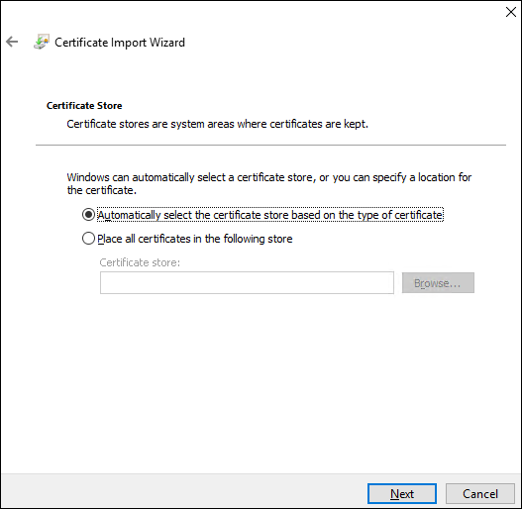

            - On the Certificate Store page:
- Select Place all certificates in the following store, as shown by (1) in Figure 7-17.
              - Certificate Store page 2
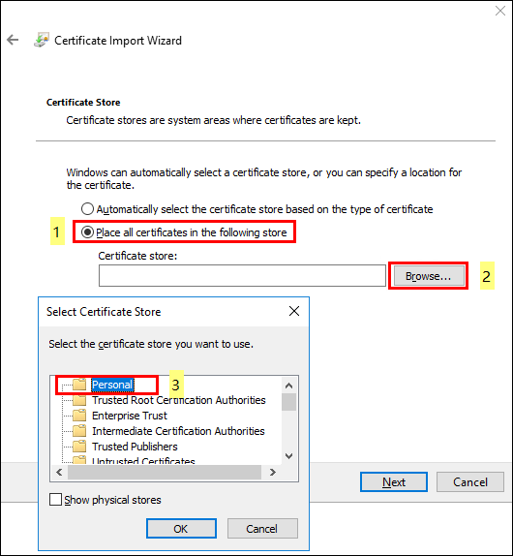

- Click Browse, as shown by (2) in Figure 7-17.
The Select Certificate Store dialog box is displayed.
- Select Personal, as shown by (3) in Figure 7-17.
- Click OK, as shown by (4) in Figure 7-17.
- Click Next, as shown by (5) in Figure 7-17.
The Completing the Certificate Import Wizard page is displayed, as shown in Figure 7-18.
              - Completing the Certificate Import Wizard page
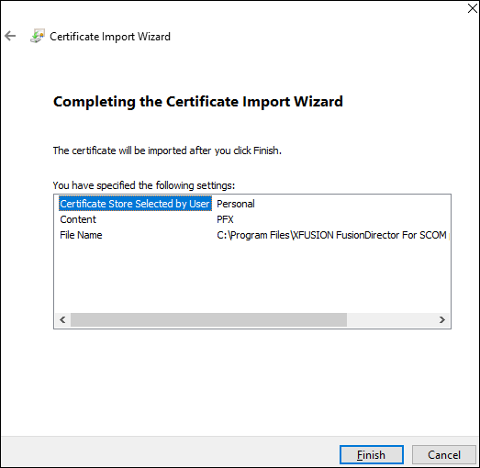

            - Click Finish to import the certificate.
A dialog box is displayed indicating that the certificate is successfully imported, as shown in Figure 7-19.
              - Imported successfully
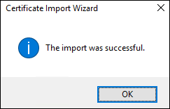

            - Click OK.
            - Run the following command to delete the existed certificate:
netsh http delete sslcert ipport=0.0.0.0:Port
Port indicates the port number set during the SCOM plug-in installation.
For example, run the following command:
netsh http delete sslcert ipport=0.0.0.0:44301
The "SSL Certificate successfully deleted" information is returned, as shown in Figure 7-20.
              - Returned information 1
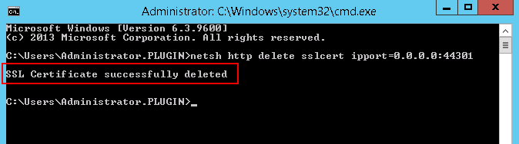

            - Copy the certificate thumbprint.
- In the server certificate list, locate and open the page for manually importing the certificate.
- On the Details tab page, find and click Thumbprint.
- Copy the displayed certificate fingerprint, as shown in Figure 7-21.
              - Copying the certificate thumbprint
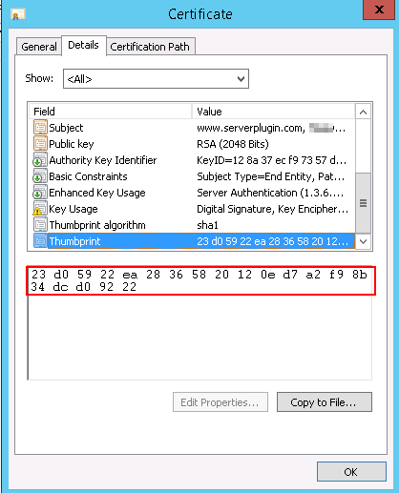

            - Run the following command to replace the certificate:
netsh http add sslcert ipport=0.0.0.0:Port certhash=Thumbprint appid={214124cd-d05b-4309-9af9-9caa44b2b74a}
- Port indicates the port number set during the SCOM plug-in installation.
- The spaces in the certificate thumbprint must be deleted.
For example, run the following command:
netsh http add sslcert ipport=0.0.0.0:44301 certhash=23d05922ea28365820120ed7a2f98b34dcd09222 appid={214124cd-d05b-4309-9af9-9caa44b2b74a}
The "SSL Certificate successfully added" information is returned, as shown in Figure 7-22.
              - Returned information 2
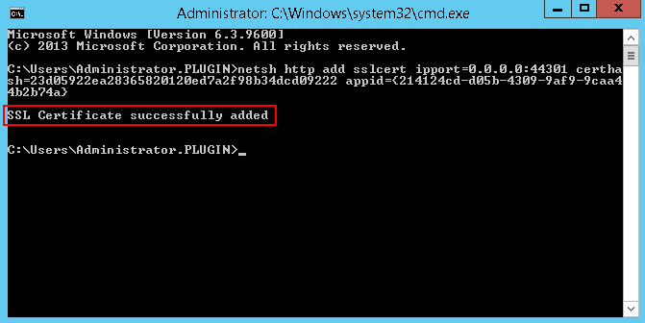

            - Restart the service.
- Open Task Manager.
- On the Services tab page, find XFUSION FusionDirector For SCOM plugin Service, as shown in Figure 7-23.
              - Restarting the service 1
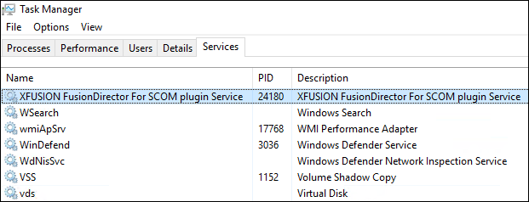

- Right-click the service and choose Restart to restart the service, as shown in Figure 7-24.
              - Restarting the service 2
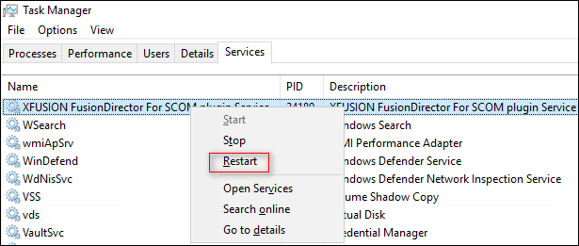

----End

What Do I Do If the System Displays a Message Indicating that the SSL/TLS Secure Channel Fails to Be Created When FusionDirector Is Added?
Symptom
When you add FusionDirector 1.6.1 or later to the SCOM Windows Server 2012 R2 server, the system displays a message indicating that the SSL/TLS secure channel fails to be created, as shown in the following figure.
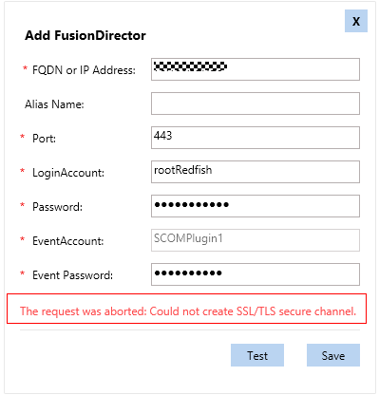
Problem Cause
The SCOM Windows Server 2012 R2 server does not contain the cipher suite supported by FusionDirector 1.6.1 or later. As a result, the SSL/TLS secure channel fails to be created when FusionDirector 1.6.1 or later is added.
Solution
Before adding FusionDirector 1.6.1 or later to the SCOM Windows Server 2012 R2 server, install the Windows OS patch (2919355) and add the cipher suite supported by FusionDirector 1.6.1 or later. The procedure is as follows:
            - Log in to the SCOM Windows Server 2012 R2 server.
            - Install the Windows OS patch 2919355.
For details about the 2919355 patch package and how to install it, see the following documents:
https://support.microsoft.com/en-us/help/2919355/windows-rt-8-1-windows-8-1-windows-server-2012-r2-update-april-2014
            - Add the cipher suite supported by FusionDirector.
To view the encryption algorithm kits supported by FusionDirector, log in to FusionDirector, and click Menu > System Settings > Security > Configuration Management. They are displayed in the TLS Cipher Suite Configuration field. For details, see the chapter Configuration Management in the FusionDirector Operation Guide.
The following uses the IIS Crypto tool as an example.
- On the SCOM Windows Server 2012 R2 server, open the IIS Crypto tool.
- Click Cipher Suites in the menu bar on the left, and then click in the operation column on the right, as shown in the following figure.
              - Cipher Suites page
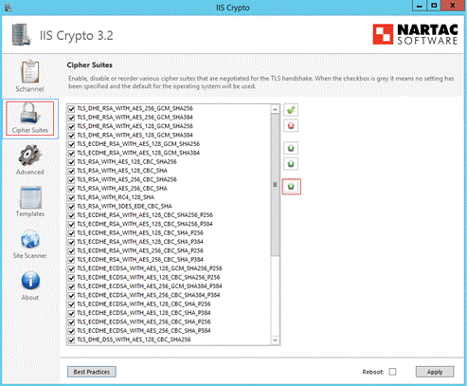

- In the Add a Cipher Suite dialog box, enter the cipher suite supported by FusionDirector, as shown in the following figure.
              - Entering the cipher suite supported by FusionDirector (example)
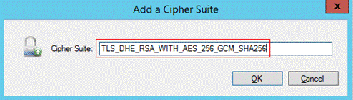

- Click OK.
- Select Reboot and click Apply for the settings to take effect, as shown in the following figure.
              - Restarting the system for the settings to take effect
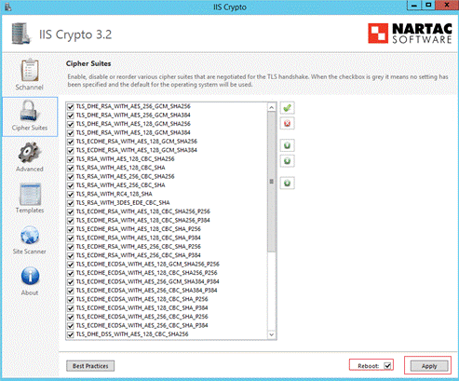

----End

How Do I Disable the Insecure TLS Protocol?
Symptom
If the system does not close the insecure TLS protocol such as TLS1.0 or TLS1.1, the plugin will generate a warning.
Solution
Disable the insecure TLS protocol as follows while ensuring software and system functions.

This operation may affect other software running properly.
The following uses IIS Crypto as an example to show how to disable the protocol.
            - Open the IIS Crypto on the SCOM Windows Server.
            - Click Schannel in the left menu and uncheck TLS1.0 and TLS1.1, shown as below:
              - Schannel interface
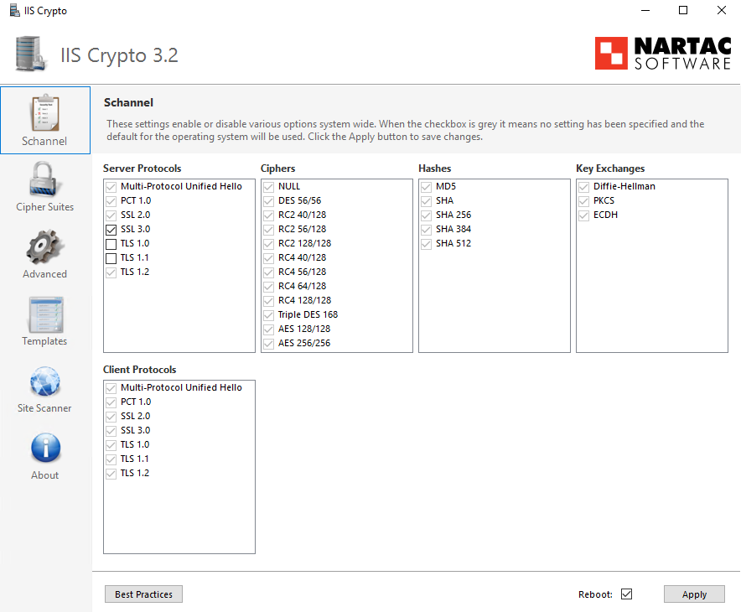

            - Check Reboot and click Apply to reboot the device. The configuration will be validated.
----End

How to Disable System Unsafe Encryption Algorithm Kits
Symptom
If some unsafe encryption algorithm kits are not disabled, bug prompts will be displayed when the safe scan is conducted.
Solution
To avoid safety risks, it is suggested to only enable safe encryption algorithm kits without affecting software and system functions.
The safe encryption algorithm kits that match with FusionDirector, log in to FusionDirector, and click Menu > System Settings > Security > Configuration Management. They are displayed in the TLS Cipher Suite Configuration field. For details, see the chapter Configuration Management in the FusionDirector Operation Guide.
The following uses IIS Crypto as an example to show how to disable the protocol.
            - Open the IIS Crypto on the SCOM Windows Server.
            - Click Cipher Suites in the left menu bar, and cancel checking unsafe encryption algorithm kits. As shown in Figure 7-29.
              - Disabling System Unsafe Encryption Kits
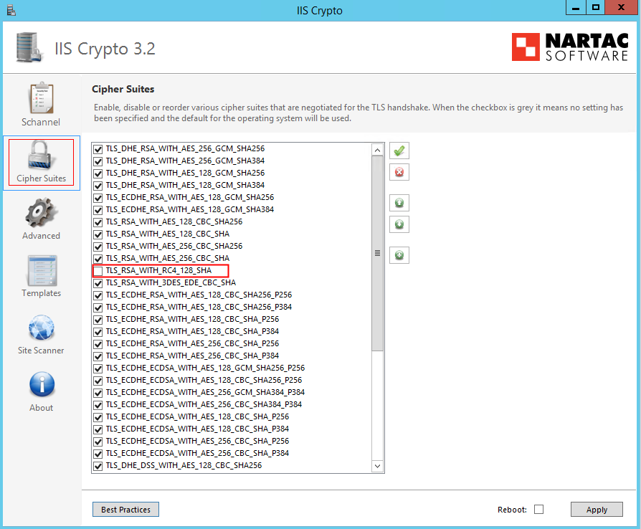

            - Select Reboot and click Apply for the settings to take effect, as shown in the following figure.
              - Restarting the system for the settings to take effect
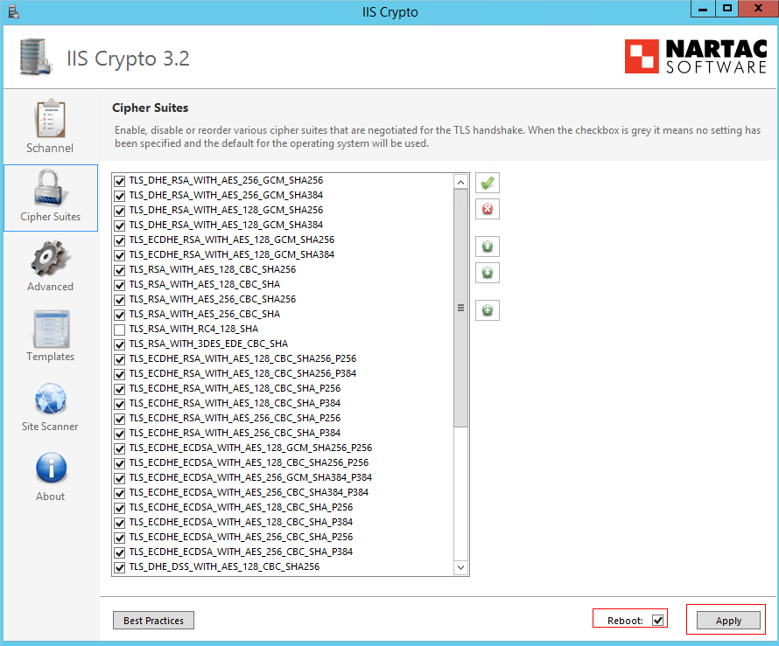

----End
- Glossary
F
FusionDirector | A unified server O&M management software.

N
NetFramework | Microsoft .NET Framework is a new hosting code programming model used for Windows. It combines powerful functions with new technologies to construct applications with excellent user experience, implement seamless communications across technical boundaries, and support various service processes.

S
SCOM | System Center Operation Manager (SCOM) refers to the Microsoft system center operation manager. SCOM monitors servers, application systems, and clients in the network. It provides a GUI for administrators to monitor faults and alarms of target computers.

- Public IP Addresses
The Public IP Addresses of FusionDirector For SCOM describes the public IP addresses of the open-source and third-party software used in FusionDirector For SCOM. For details, see Table Public IP Addresses of FusionDirector For SCOM.
                - Public IP Addresses of FusionDirector For SCOM
Component | URL | Function
NSIS | http://nsis.sf.net/ | This URL links to NISI's official website. It will not be triggered by any public address.
NSIS | https://schemas.microsoft.com/* | This URL links to document type definition for reference purpose. It will not be triggered by any public address.
NSIS | http://*.microsoft.com/* | This URL links to Microsoft's official website. It will not be triggered by any public address.
iisexpress | https://www.iis.net/ | This URL links to IIS's official website. It will not be triggered by any public address.
Microsoft.EnterpriseManagement.Core.dll | http://tempuri.org/* | This URL links to document type definition for reference purpose. It will not be triggered by any public address.
Microsoft.EnterpriseManagement.Core.dll | http://www.w3.org/* | This URL links to document type definition for reference purpose. It will not be triggered by any public address.
Newtonsoft.Json | http://james.newtonking.com/projects/json | This URL links to author blogs on Newtonsoft.Json. It will not be triggered by any public address.
Newtonsoft.Json | https://www.newtonsoft.com/* | This URL links to Newtonsoft.Json official website. It will not be triggered by any public address.
Newtonsoft.Json | https://www.nuget.org/* | This URL links to Nuget's official webiste. It will not be triggered by any public address.
Newtonsoft.Json | https://*.digicert.com/* | This URL links to Digicer's official website. It will not be triggered by any public address.
Nlog | https://nlog-project.org/* | This URL links to Nlog's official website. It will not be triggered by any public address.
Nlog | http://schemas.xmlsoap.org/* | This URL links to document type definition for reference purpose. It will not be triggered by any public address.
Nlog | http://schemas.datacontract.org/* | This URL links to document type definition for reference purpose. It will not be triggered by any public address.

- Obtaining Technical Support
To obtain assistance, contact technical support as follows:
- Contact customer service center at support@xfusion.com.
- Contact technical support personnel.
- Communication Matrix
Source Device | Source IP Address | Source Port Number | Destination Device | Destination IP Address | Destination Port Number | Protocol | Port Description | Destination Port Configurable | Authentication Mode | Encryption Mode
Device of the plug-ins | Device IP address of the plug-ins | Random | Device to which FusionDirector belongs | IP address of the device to which FusionDirector belongs | 443 | TCP | HTTPS (web) port, the protocol can be modified.Plug-in, as a client, accesses the FusionDirector server. | No | Token | TLS
Client | Client IP address | Random | Device of the plug-ins | Device IP address of the plug-ins | 44300-44399  Note: The port number ranges from 44300 to 44399. | TCP | The port that receives the report events of FusionDirector is enabled by default to 44301. | Yes | User name and password | TLS

